**Basic admin Vue site requirements**

**Web app desctiption:**

The admin site will allow the admin to create tasks and assign them to the workers. The workers will report their movement by GPS coordinates, and they will be shown on a map in the task details page.

**What`s done already:**

1. Login page is done (via Firebase)
2. Database access is done (via Firebase and I will provide a method call for each operation)
3. Full admin site UI is done (by the Vuely Vue theme). All HTML elements needed are there, you just need to reuse them.

Link to theme overview: <https://preview.themeforest.net/item/vuely-vuejs-admin-template/full_screen_preview/21247764?_ga=2.142460274.1102939581.1584186152-1030614129.1580057226>

<https://themeforest.net/item/vuely-vuejs-admin-template/21247764>

Link to theme demo: <https://vuely.theironnetwork.org/default/dashboard/ecommerce>

**What`s needed:**

Basically just call the DB (calls provided by me) and create the HTML element according it.

Visual overview of the pages that needs to be created is in the next page:

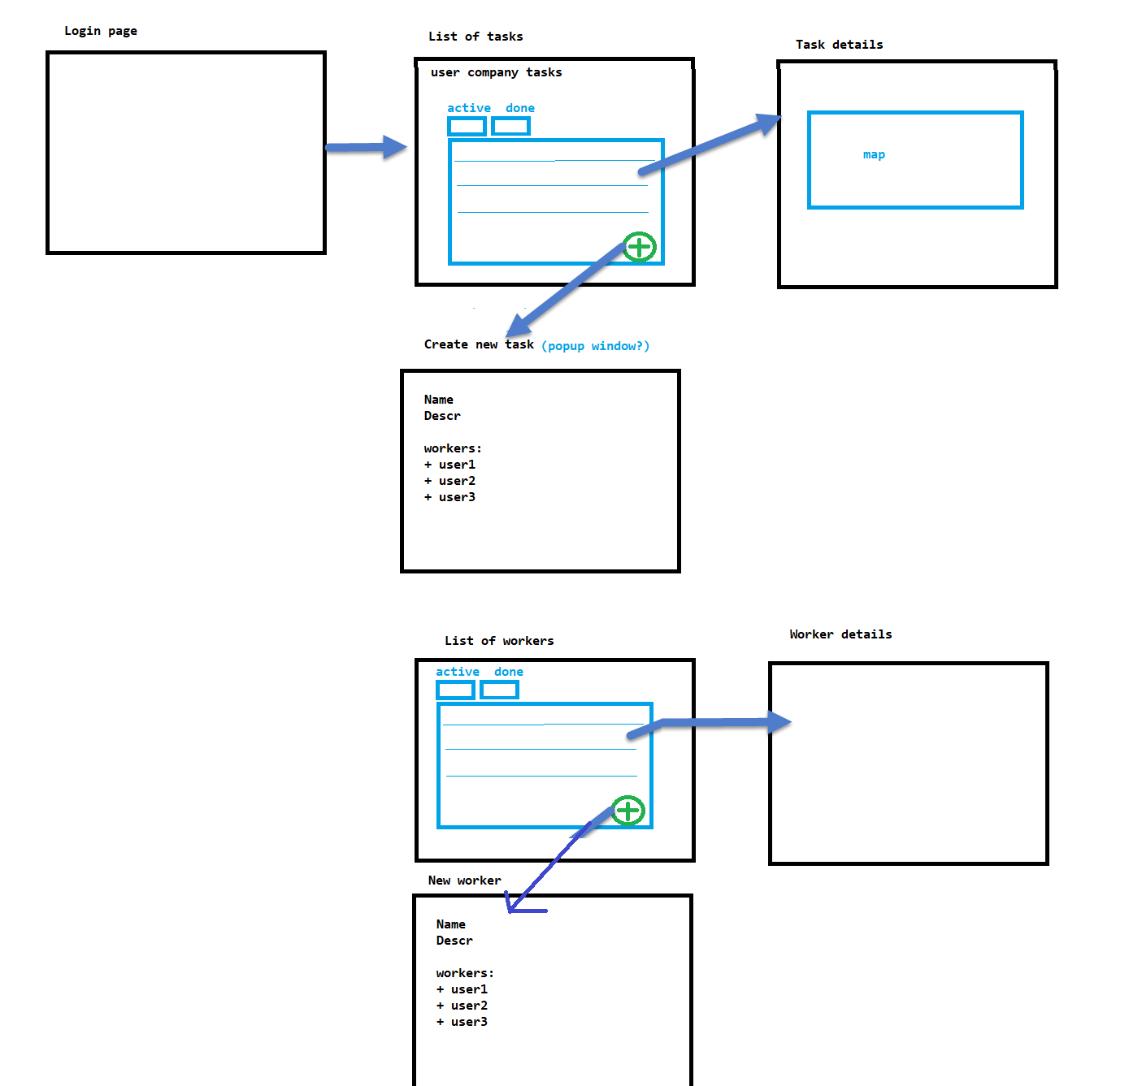

**Business requrement description:**

We have a need for an admin site that will control a creation of tasks that workers will work on. The workers are uploading live coordinates records to the task.

The admin belongs to a company and he can create workers in that company. Also he can create tasks and assign workers to those tasks. The workers starts working on the task by uploading coordinates to it.

**Web pages needed to be created:**

* 1. Tasks page
  2. Task details page (task info + map is shown where coordinates from firebase needs to be displayed)
  3. New task creation page
  4. Workers page
  5. Worker details page
  6. New worker page

1. **Workers tasks page**

So this page shows all tasks from the logged in user`s company (from table CompanyTasks). The company of the logged in user can be found in (Here Meto Metovski is the logged in admin):

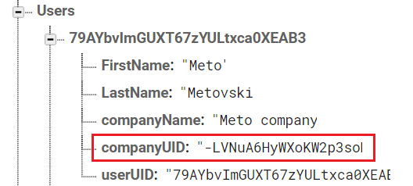

The grid showing all tasks from a company should be placed in Tab control, with 2 tabs: Active/Pending and Completed.

The data grid should show the following data:

1. TaskId (string)
2. Task start (datetime)
3. Task description (string)
4. ClientId (string)
5. Status (string)

The data in the grid should be sorted by 2 fields:

1. Task start (type: datetime)
2. Status (type: string)

**Overview**:

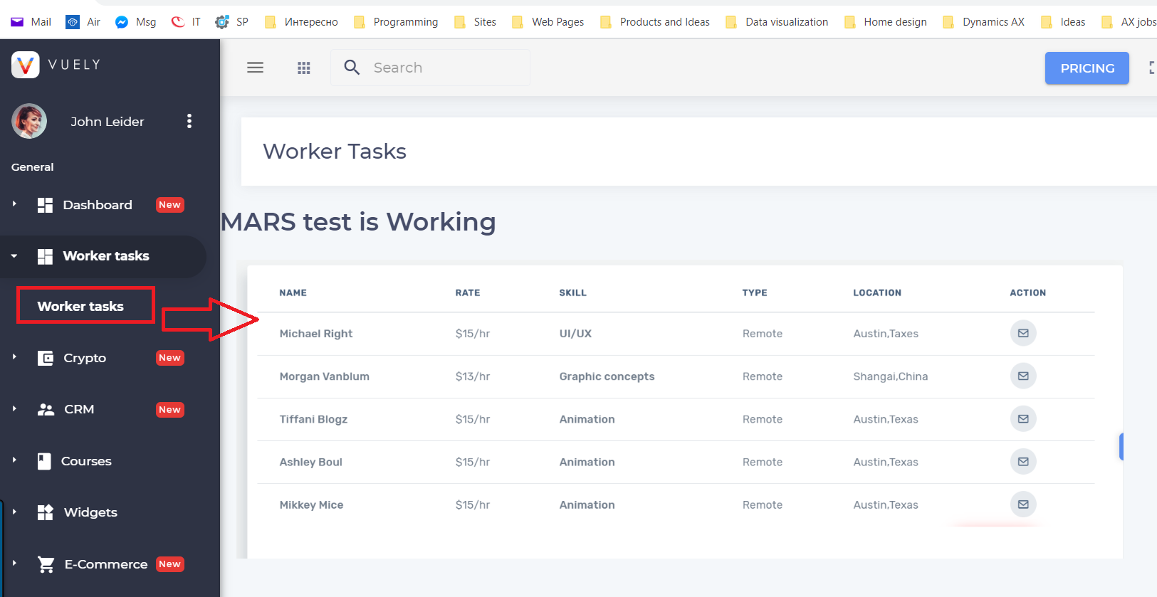

**Detail UI:**

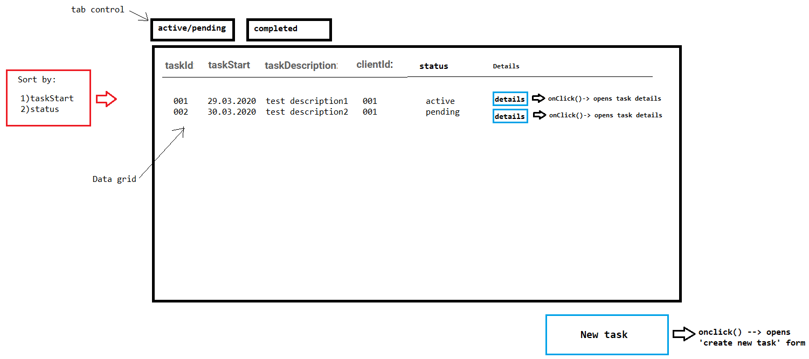

There should be a button for creating a new task **(point 2 below).**

If the user clicks a button on a grid line (details button), or the #ID of the task, it should redirect him to the task details page. **(point 3 below)**

1. **New task page**

Herethe admin can add a new task by providing the following data:

1. Task description
2. List of workers that`s going to work on the task (in a listview or something)
3. Date

The workers that will work on the task should be added in a list by some way (either by openning a popup view that allows the user to insert a worker, or something else, you can choose the control/way to do it). Also it should be enabled that a user can be removed from a task by pressing (X) on the user box.

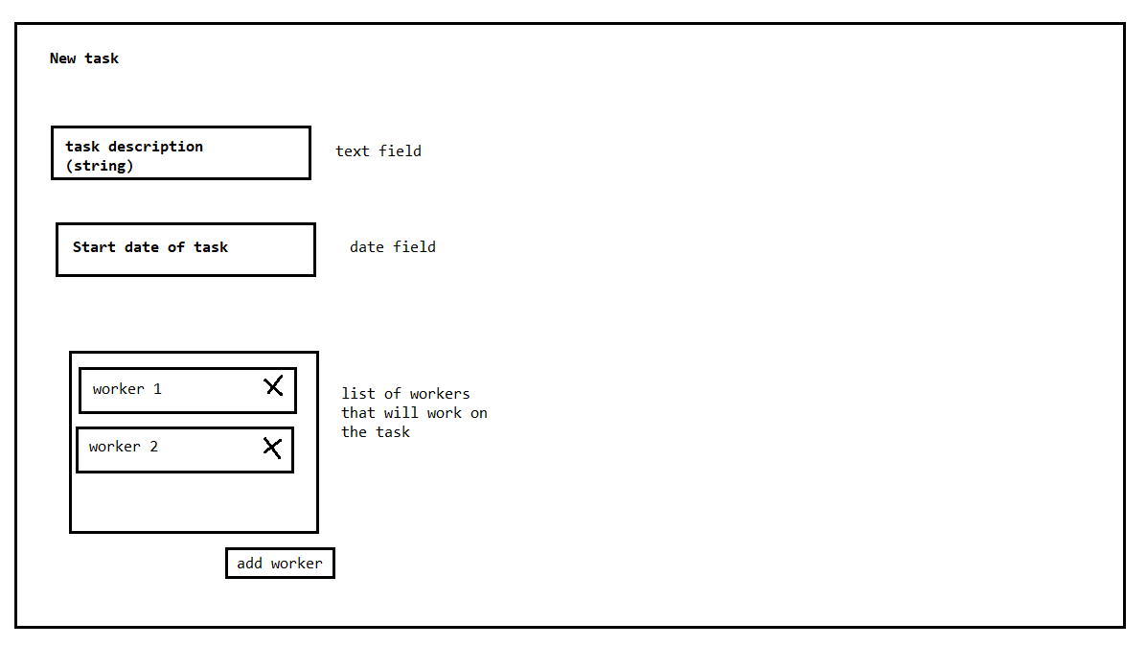

1. **Task details page.**

It should show a list of all users working on that task, the task details (name description etc), and a map where the worker coordinates from that task will be shown in **real time**.

The workers will upload the coordinates from a mobile app, the Vue site should only display them in real time.

**Detail UI**

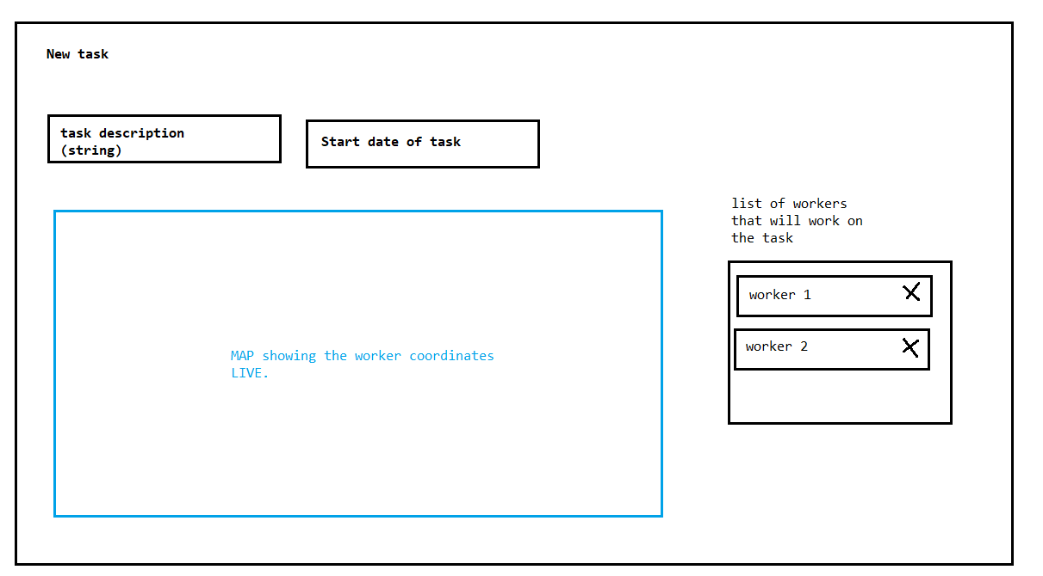

DB table from where the coordinates are pull:

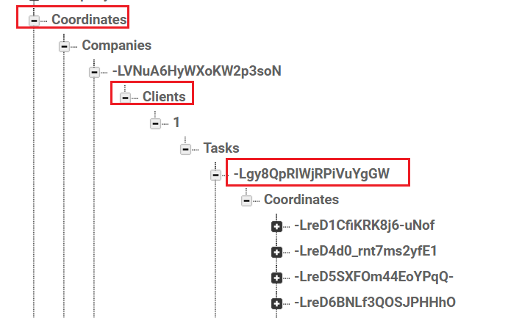

1. **List of workers**

This is a page where all workers from the logged in user`s company are listed (in a grid), and it also has to be in a Tab control with 2 tabs (active/non active). The Firebas table is “CompanyWorkers”.

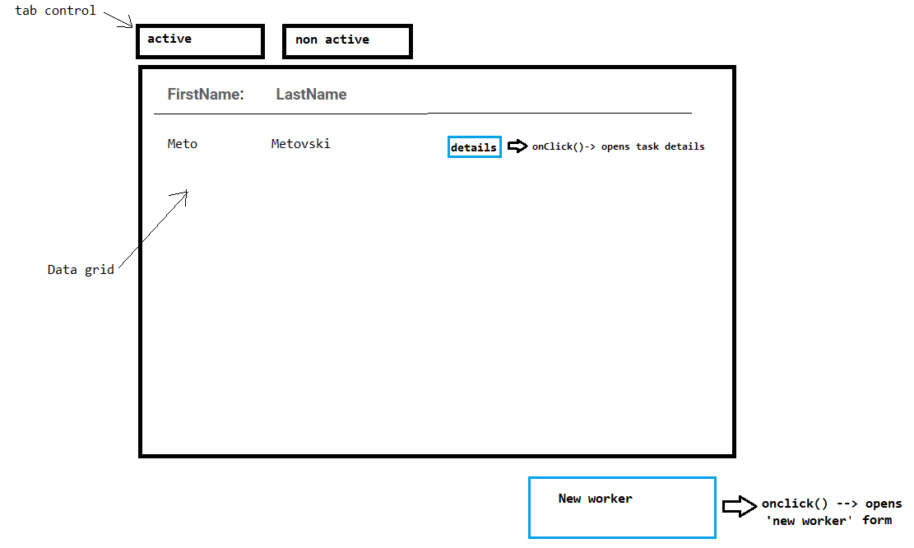

There should be a button on each grid row that will redirect to the worker details page.

There should be a button on the form (below the grid) that will redirect to the create new user form **(point 5)**

1. **Worker details**

Simple workerd details form where the selected worker data is shown:

* + - Name
    - Surname
    - Company name

Also a back button should exist where the user can navigate back to the worker list.

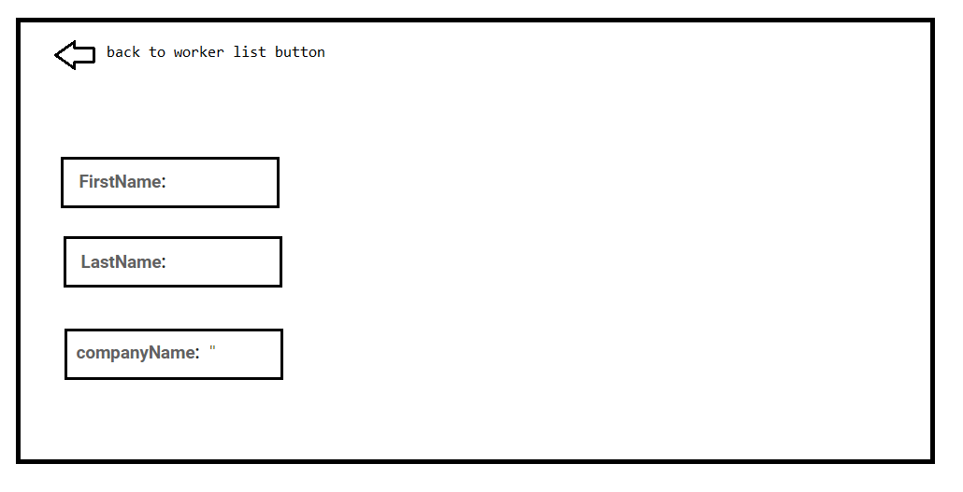

* 1. **New worker page**

Here the admin enters basic data for the user that he wants to create, and clicks Save button. When he clicks save button, the user is saved and the UI redirects it back to the ‘List of users’ page.

Also there should be a cancel button, if pressed it goes back to the ‘List of users’ page.

